Full Stack MERN Assignment – Smart Reconciliation & Audit System

🔹 Project Title:
Smart Reconciliation System
🔹 Description:
A full-stack web application that allows users to upload CSV transaction files and automatically perform reconciliation. The system detects matched, unmatched, duplicate, and partially matched transactions and provides visual analytics through a dashboard.
🔹 Features:
- JWT Authentication
- Role-based access
- CSV Upload (Multer)
- Background Processing
- Automatic Reconciliation Logic
- Dashboard Analytics (Charts)
- Reconciliation Table View
🔹 Tech Stack:
- React.js
- Node.js
- Express.js
- MongoDB
- JWT
- Multer
- Recharts

Screenshots of my project:

1. Login Page:

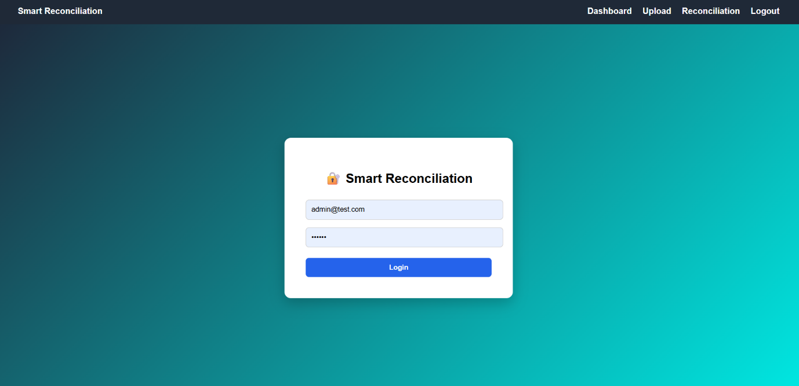

2. Dashboard Page:

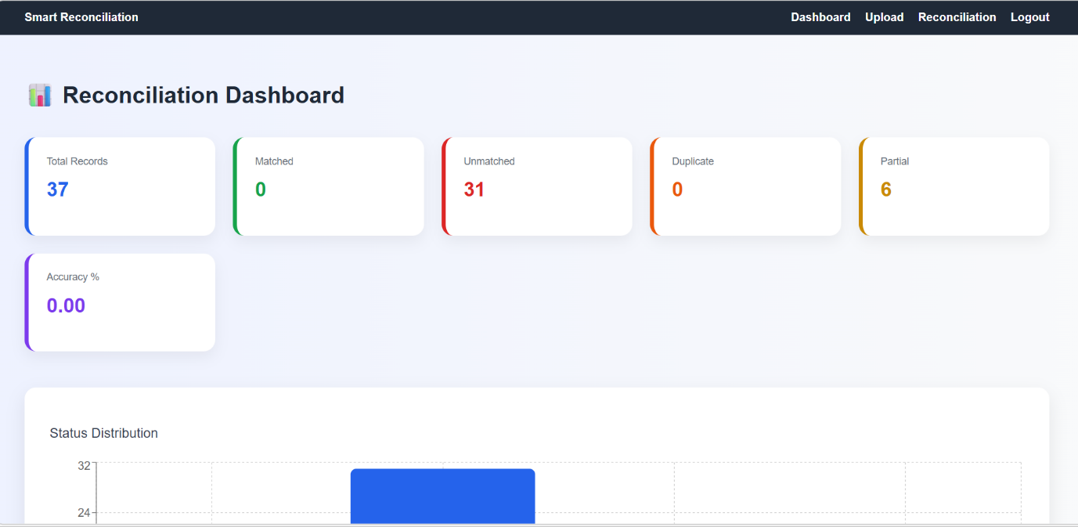
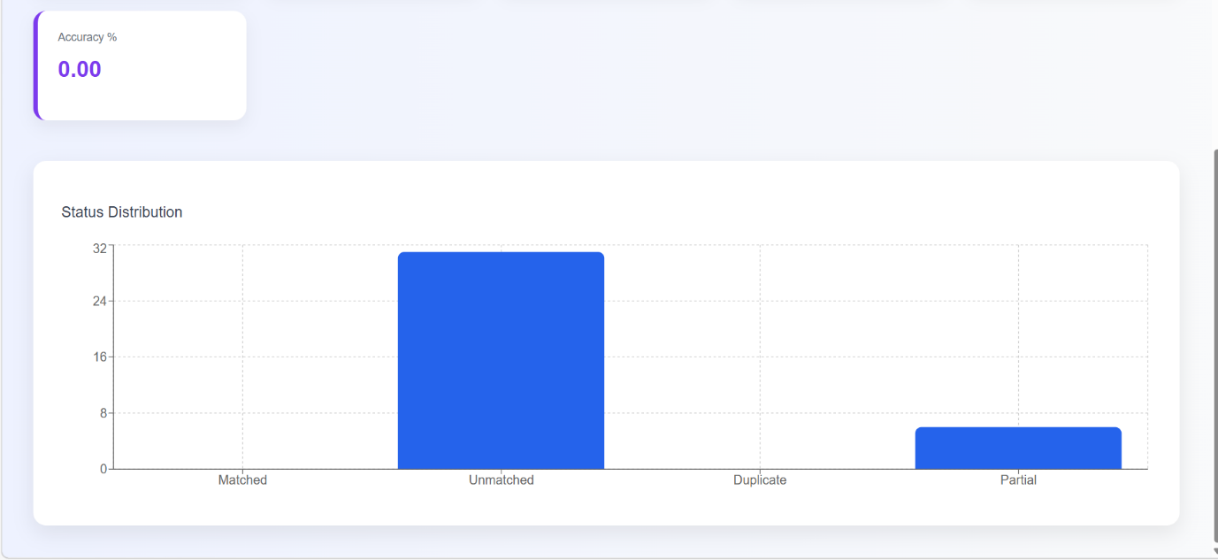

3.Upload page:

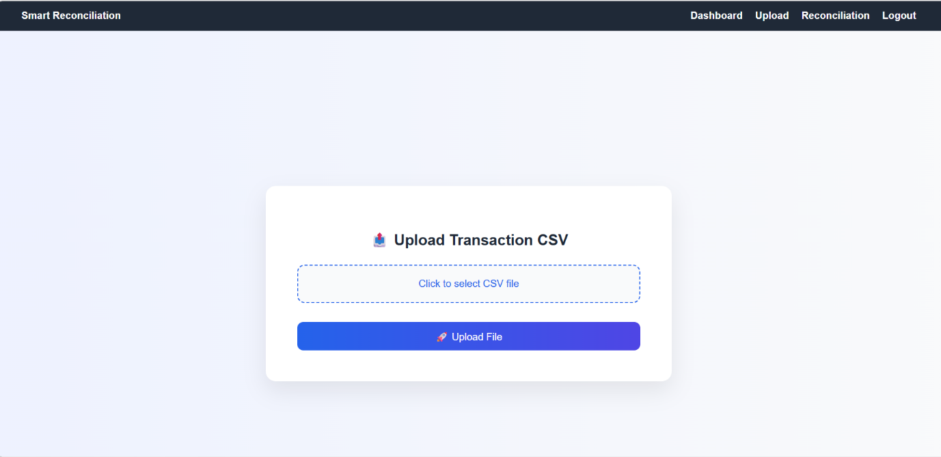

4. Reconciliation Table page:

